*NOTE: Be sure to read this week’s PPT slides and Chapter 10 in the 100 textbook.  
 Also first read the Packet Tracer notes at the end of this lab.*

**Objectives**

* Investigate the workings and initial commands for simple VLANs.   
    
  For this lab you will only submit a packet tracer file (in PKA format), not a word document.

**A - Create the Topology**

* Download the file “04Lb-VLAN Introduction.pka” from iLearn.

This is a CISCO provided exercise which has its own special ‘activity’. We’re going to do some of that activity plus some additional activity. **Ignore the activity window when it pops up – just minimize it whenever it pops up.**

* Open a TEXTBOX and place your name-id on the topology.

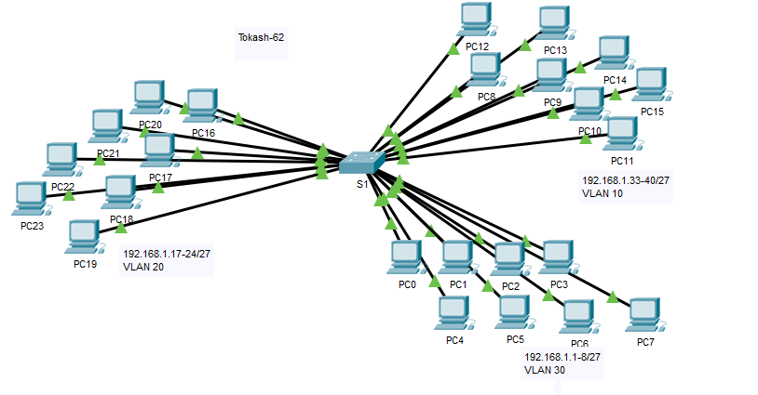

**B – Observe Broadcast Traffic in a VLAN via PING Commands**

* Click **PC0** and click the **Desktop** tab> **Command Prompt**.
* Enter the **ping 192.168.1.8** command. The ping should succeed.
* Enter the **ping 192.168.1.18** command. The ping should not succeed.

Why do you think the first ping was successful but the second ping failed?

**B – Observe Broadcast Traffic in a VLAN via a Complex PDU Simulation**

* Switch to **Simulation** mode.
* Click **Edit Filters** in the Simulation Panel. Uncheck the **Show All/None** checkbox. Check the I**CMP** checkbox.
* Click the **Add Complex PDU** tool, this is the open envelope icon on the right toolbar.
* Float the mouse cursor over the topology and the pointer changes to an envelope with a plus (+) sign.
* Click **PC0** to serve as the source for this test message and the **Create Complex PDU** dialog window opens. Enter the following values:

• Destination IP Address: 255.255.255.255 (broadcast address)

• Sequence Number: 1

• One Shot Time: 0

* Click **Create PDU**. This test broadcast packet now appears in the **Simulation Panel Event List.** It also appears in the PDU List window. It is the first PDU for Scenario 0.
* Click **Capture/Forward** twice. What happened to the packet?
* Repeat this process for **PC8** and **PC16**.

**C – Exploring CLI Commands**

* Click on the switch and enter CLI mode.
* In enable mode enter the command “SHOW INTERFACE STATUS”. We’ve used this command previously. What’s different now?
* Enter the command “SHOW VLAN BRIEF.” You should see that the FACULTY VLAN has 8 ports.
* Let’s create a new VLAN. In configuration mode
  + Enter: VLAN 9
  + Enter: NAME Deans
* CTL/Z and enter “SHOW VLAN BRIEF.” You should see the new (but empty) VLAN created.
* Now we’ll move ports 17 to 19 to it. In configuration mode:
  + Enter: interface range f0/17-19
  + Enter: switchport access vlan 9
* CTL/Z and enter “SHOW VLAN BRIEF.” You should see the new VLAN with the three ports assigned.

**D – Final challenge and lab submission**

* Using what we’ve done above, create a new vlan - VLAN 21 – and name it your last name, then move port 9 into vlan 21.
* Open a text box and write “NEW COMMANDS”. List the new commands you used for this lab.
* Open a second text and write “REFLECTION”. Write why one might use VLANS on their home network?
* Save your packet tracer file. Use the SAVE AS option and name it “L4b–*yourlastname”*
* For this lab submit only the saved packet tracer PKA file.

**A Few Notes on Packet Tracer**

* If you are in simulation mode and want to clear/delete a previously initiated PING or PDU request, first expand the “PDU LIST WINDOW by clicking the left arrow at the bottom of Packet Tracer .

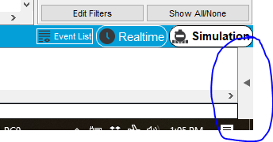

* Once the window is pen you can click on the DELETE icon

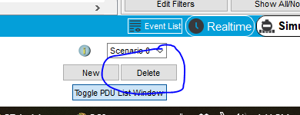

*\*\*\* End of Lab \*\*\**